**Magyar Posta Zrt.**

**Letter Product Management Directorate**

**Letter Product Management Department**

TELJES

**Technical guide to the production of unique barcode identifiers for identified (ordinary) letter mail items by the sender**

Version number: 1.5

Budapest, 2019

**Contents**

1. Purpose of the guide 3

2. Production guide 4

2.1. Parameters and elements of the item identifier print 4

2.2. The barcode 5

2.2.1. Structure and data content of the barcode 5

2.2.2. Standards compliance 7

2.2.3. Division of the barcode 7

2.2.4. Size parameters of the barcode 7

2.2.5. Colours used for barcode printing 7

2.2.6. Print quality of the barcode 8

2.2.7. Recommended code optimization procedure 8

2.3. Specifications for other data elements 8

2.3.1. Data element parameters 8

2.3.2. Identification number below the barcode 9

2.4. Position of the barcode item identifier on the mail item 9

2.5. Window envelope 9

2.6. Printing address data and barcode item identifiers on the same label 10

3. Allocation and registration of identifier ranges 11

4. Compliance of the barcode item identifier 11

# Purpose of the guide

For the purpose of uniquely identifying the so called Identified ordinary letter mail items in postal processing, Magyar Posta Zrt. uses a barcode item identifier.

Thanks to the use of barcode technology, the application of barcode item identifiers further improves the speed, accuracy, and security of the postal processing of these mail items, but the technical requirements laid down in this guide must be fully implemented in order to achieve these benefits.

Barcode item identifiers defined in this guide can be used on identified ordinary mail items accepted for domestic delivery.

Magyar Posta Zrt. offers its contractual partners the option to have barcode item identifiers, suitable for postal processing, printed on their mail items.

This technical guide provides assistance to contractual partners and print shops producing the mail items with the production of barcode item identifiers. All issues related to physical parameters that are not included in this guide are subject to the specifications of the referenced standards.

Magyar Posta Zrt. reserves the right to change the data and requirements in this technical guide at any time.

We hope that this Guide will help make dispatching mail easier for you.

Magyar Posta Zrt.

Letter Product Management Department

# Production guide

## Parameters and elements of the item identifier print

Magyar Posta Zrt. uses barcoded item identifiers as shown in figure 1 to apply unique identifiers to identified ordinary letter mail items (hereinafter: identified letter mail items) submitted for postal delivery.

C:\Users\juhaszv\AppData\Local\Microsoft\Windows\INetCache\Content.Outlook\P78CPRXH\KA_szemlelteto (002).tif

*Figure 1: Example of a barcode item identifier (not to scale,  
only for demonstration)*

The maximum overall size of the barcode item identifier print is 80 x 20 mm.

The print of the identifier should be enclosed in a frame made up of lines at least 1 pt thick in order to ensure that it is clearly distinguishable from any other information appearing on the mail item.

The barcode item identifier consists of the following elements:

* Barcode
* Letter “A” indicating the item type
* Identification number below the barcode (human readable content of the barcode)

Letter indicating mail item type Barcode

*C:\Users\juhaszv\AppData\Local\Microsoft\Windows\INetCache\Content.Outlook\P78CPRXH\KA_alap_informaciok (002).tif*

Identification number below the barcode

*Figure 2: elements of a barcode item identifier*

## The barcode

### Structure and data content of the barcode

Structure and data content of the barcode are as follows:

Standard(s): CODE 128 (in accordance with ISO/IEC 15417)

Length of data: 16 characters

Example of an identification number: KA 7201 123 456 789 5

Structure:

|  |  |  |  |
| --- | --- | --- | --- |
| Character position: | Name: | Type | Value |
| Positions 1 to 2 | Item type identifier | Character based | „KA” |
| Positions 3 to 6 | Special customer identifier | Numeric | 4 digit |
| Positions 7 to 15 | Individual number | Numeric | 9 digit |
| Position 16 | CDV check number | Numeric | 1 digit |

At position 1 and 2 the barcode includes the value of the “item type identifier”: KA

At position 16 the barcode item identifier includes a CDV check number. CDV checksums should be generated for the “unique identification number” part of the identifier (position 7-15) by using the following algorithm:

* numbers at odd positions shall be multiplied with 3, proceeding from left to right (step 1),
* numbers at even positions shall be multiplied by 1, proceeding from left to right (step 1),
* the products must be added up (step 2),
* operation MOD10 must be carried out on the result (step 3).

Example: 123456789 (characters 7-15 of the identifier)

|  |  |  |  |  |  |  |  |  |  |
| --- | --- | --- | --- | --- | --- | --- | --- | --- | --- |
| Step 1: | 1 | 2 | 3 | 4 | 5 | 6 | 7 | 8 | 9 |
| sign of multiplication | x | x | x | x | x | x | x | x | x |
| Multiplier | 3 | 1 | 3 | 1 | 3 | 1 | 3 | 1 | 3 |
| Result. | 3 | 2 | 9 | 4 | 15 | 6 | 21 | 8 | 27 |
| Step 2: | +3 | +2 | +9 | +4 | +15 | +6 | +21 | +8 | +27 |
| "Összeg" (Amount): | =95 | | | | | | | | |
| Step 3:  (MOD10) | The remainder obtained from the MOD10 operation performed on the product of multiplication will be the CDV check number of the identifier:  95 divided by 10, remainder = 5 | | | | | | | | |
| Thus, the CDV check number in this example is: 5 | | | | | | | | | |

### Standards compliance

The barcode item identifier shall comply with the requirements of the applicable national, international and postal standards. Regarding the technical parameters of barcodes, the provisions of the standard ISO/IEC 15417 *„Information technology - Automatic identification and data capture techniques - Code 128 bar code symbology specification”* are applicable. (The applicable standard can be purchased from the Hungarian Standards Institution: www.mszt.hu).

### Division of the barcode

The barcode content must not include any internal divisions and delimiters (zeros, spaces etc.) other than the useful information content and the special characters specified in the barcode standard. Individual characters must be encoded contiguously, without any division.

### Size parameters of the barcode

|  |  |
| --- | --- |
| Width of the leading and trailing light coloured fields (quiet zones) separating the barcode from other data, both before and after the barcode: | 6.3 mm |
| Smallest line height of the barcode: | 10.0 mm |
| Minimum barcode module size (width of the narrowest line): | 0.37 mm (but at least 0.34 mm) |
| Minimum resolution of the printer used to produce the barcode: | 300 dpi |

### Colours used for barcode printing

Colours used for barcode printing:

* line colour: black,
* space colour between lines: white.

Printing of the barcode in several colours (multicolour) is forbidden. Inverse printing of the barcode is also forbidden, lines must be dark, spaces must be light in all cases.

### Print quality of the barcode

Effort must be made to achieve the best possible print quality, which is paramount in terms of the readability of the barcode. Other characteristics of the carrier material and the production technology may not compromise the readability of the barcode.

The area where the barcode is placed should be clean, light, homogeneous and dull coloured.

Due to the nature and characteristics of its use, high resistance to wear and rubbing is an essential requirement, which ensures that even after being subjected to the physical impact of postal handling, printed information remains readable during the full term of its use. The applied ink must be non-smearing, undeletable, and black coloured. The information carrying lines and paces must have a definite contrast and be separated from each other and from the background in a marked way. The lines must have sharp contours and homogeneously saturated black colour.

Faulty parts and spots may hinder the accurate reading of the barcode (and thereby the recovery of the coded information content), and therefore highlighted are must be taken to avoid their frequent occurrence in the barcode print.

### Recommended code optimization procedure

In order to ensure better use of the available space, Magyar Posta Zrt. recommends using the code optimization procedure permitted by the standard CODE-128 (double density encoding of numbers - two digits with a single character - in the barcode is limited to representing numeric characters with code set “C”) in the production of the barcode. This method allows the data content of the item identifier to be stored in a smaller space, using a barcode with the same module size.

An example of using code optimization in practice:

* Data content of the barcode: KA72011234567895
* Coding schema (the meaning and calculation of symbols in brackets are described in the standard ISO/IEC 15417):

{START B}KA{VÁLT C}72|01|12|34|56|78|95{JELKÉPELLENŐRZŐ}{STOP}

## Specifications for other data elements

### Data element parameters

|  |  |
| --- | --- |
| Letter “A” indicating the item type | Typeface: Times New Roman  Size: 36 pt  Position: At the left side of the barcode, outside the quiet zone  Color: Black |
| Identification number below the barcode | Typeface: Avenir or Arial CE  Size: 11 pt  Position: Centered, below the barcode  Color: Black |

### Identification number below the barcode

The entire data content of the barcode appearing in the mail item identifier print (including the CDV check number) must be indicated below the barcode in human readable form. Placement of the barcode should not separate it from the human readable identification number.

The human readable identification number should be composed as follows:

* Data content of the barcode: KA72011234567895
* Division of human readable identification number: KA 7201 123 456 789 5

## Position of the barcode item identifier on the mail item

Barcode item identifiers must be printed horizontally, parallel to the longer edge of the envelope, on the face side of the letter mail item.

Without exception, the entire identifier must appear on the face side of the mail item and may not even partially cover the address. There must be an empty space at least 15 mm high between the identifier and the bottom edge of the mail item (as a reserved area for automated postal barcode processing) where no markings, indications, labels, or graphics may be placed.

No barcode other than the postal item identifier may be placed on the face side of the mail item without the prior permission of Magyar Posta Zrt.

## Window envelope

If a window envelope is used, during the production of the mail item the barcode can be placed above the data of the addressee on the envelope so that both the barcode and the entire address will remain fully and clearly visible and readable.

If a double-window envelope or an envelope with a double-width window is used, the barcode may be placed in the left side window or in the left-side part of the window cut-out (below the addressee’s data), and the same is applicable to envelopes that have the window cut-out on the left side.

Requirements:

* the window cut-out must be positioned on the side of the envelope with an unbroken surface, i.e. which has no sealing flap;
* the window cut-out must be rectangular, but rounded corners are permissible;
* the window material must be suitable transparent, with a transparency level above 80%;
* there should be no coloured zone or frame around the window cut-out, and if the envelope is coloured, then a white strip at least 5 mm wide should be present, however if a coloured strip or frame is used, then a quiet zone at least 5 mm wide should be used;
* the window material should be glued so that it is aligned with the base paper of the envelope along the cut-out without any gaps;
* the correct window size should be selected to ensure that even if the content of the envelope moves, the barcode item identifier and the address data remains visible in the window cut-out (we suggest that a 45 x 90 mm window cut-out should be used);
* in the window cut-out, subject to permission from Magyar Posta Zrt., any other barcoded customer identifier may only be used near the postal barcode item identifier if such a barcode is not generated and presented according to CODE 128, and positioned next to the address zone, at a distance of 5 mm;
* adding a frame to the mail item identifier print may be omitted on a window envelope (figure 4).

Other parameters of the barcode and the data elements are subject to provisions of point 2.2 and 2.3.

## Printing address data and barcode item identifiers on the same label

If address data are printed on a separate label before it is placed on the envelope, then the barcode item identifier may be printed on the same label above the address data. In such a case, the envelopes layout is the same as the layout of a window envelope (figure 4).

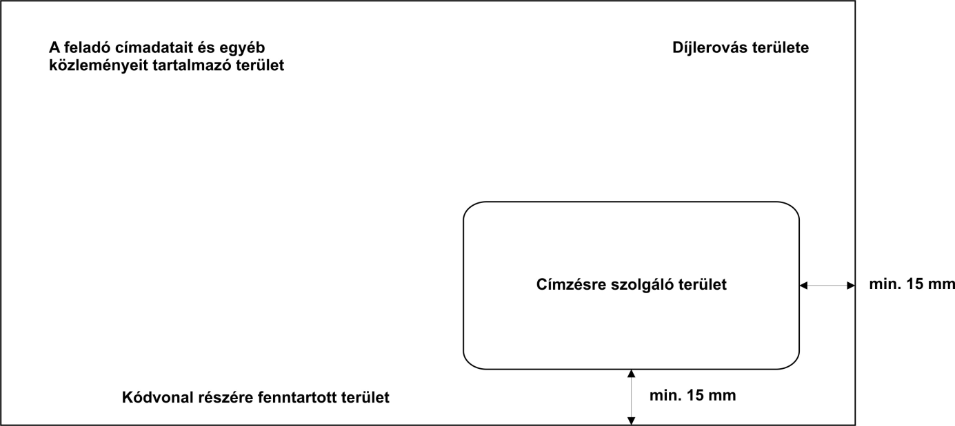

*Figure 3: Areas on the face side of a window envelope*

*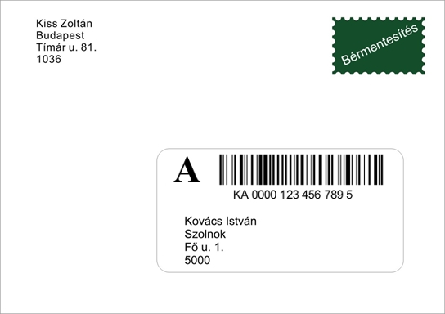*

*Figure 4: Face side of a window envelope (example)*

# Allocation and registration of identifier ranges

In the case of barcode item identifiers, the uniqueness of mail items is ensured by the entire content of the barcode. “Unique serial numbers” of item identifiers may not recur within 12 months from dispatch.

For contractual customers, available identifier ranges are allocated and registered by Magyar Posta Zrt. Mail items may only be dispatched through postal services if they bear a mail item identifier within the identifier range assigned to the given type of item.

# Compliance of the barcode item identifier

It is not necessary to submit identified mail items described in this technical guide to a preliminary inspection of the mail item identifiers by the Post. An exception from this rule is if the mail item identifier is placed in the window cut-out of a machine processing-compatible window envelope, and in this case the mail item must be re-checked due to the changes made within the window cut-out.

Compliance of mail item identifiers is checked at the time of accepting the mail item by random sampling.

Suitability of the barcode is always the sender’s responsibility. If the barcode is not suitable, the mail item is deleted from the posting list at the time of acceptance, and it will be processed as an extra mail item that is subject to normal, paper-based franking. At the time of delivery, the incorrect barcode will not be scanned by the postman and as a result, the related electronic service will be unavailable for such mail items due to the unsuitability of the barcode.

If you have questions regarding the production of the mail identifier, please contact the test laboratory of Magyar Posta: **Magyar Posta Zrt. National Logistics Centre**

**Operations Department**

Premises: Budaörs, Gervay Mihály u. 9-11.

Postal address: OLK Bevizsgáló Labor, Budaörs 1000

Tel.: +36-1-767-7537

Fax: +36-23-445-915

Mobile: +36-30-770-7272

E-mail: [bevizsgalo@posta.hu](mailto:bevizsgalo@posta.hu)