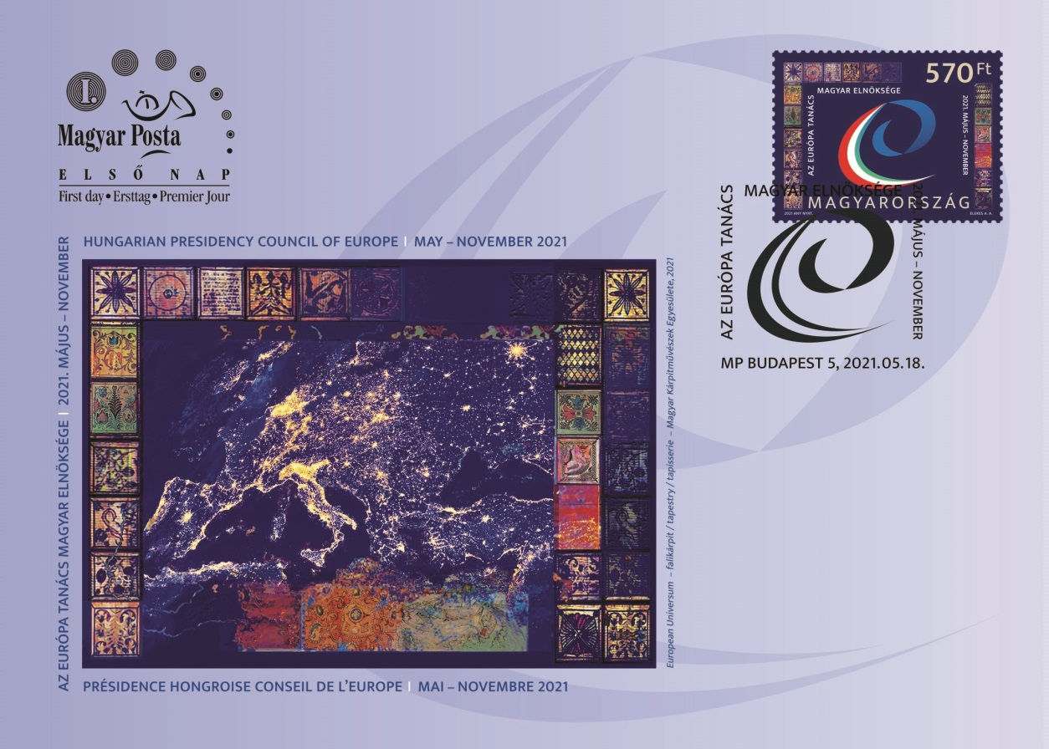
HUNGARIAN PRESIDENCY OF THE COUNCIL OF EUROPE
Magyar Posta is issuing a special stamp to mark the Hungarian Presidency of the Council of Europe in 2021. Fifty thousand copies of the stamp designed by the graphic artist Attila André Elekes were produced by ANY Security Printing Company. The new issue can be purchased from Filaposta, philately specialist services, certain post offices and www.posta.hu.  The Council of Europe, whose seat is in Strasbourg, was established on 5 May 1949 and currently has 47 members. The regional international organisation is an advocate of human rights, democracy and the rule of law. Hungary joined the organisation on 6 November 1990 as the twenty-fourth member and the first of the Eastern Bloc countries. Between May and November 2021, Hungary will carry out the tasks of the presidency of the Committee of Ministers of the Council of Europe, the second time the country has done so. During the six months of the Hungarian presidency, our priorities will be the efficient protection of the national minorities, the future generation, inter-religious dialogue, the challenges of the future and the environment (Government Decree 1616/2020 of 1 October 2020).  The main motif of the stamp is the official logo of the presidency framed by details of the tapestry called European Universum, which was commissioned by the Ministry of Foreign Affairs and Trade on the occasion of the Hungarian presidency of the Council of Europe in 2021. The commemorative first day cover shows the entire tapestry with a satellite image of Europe at night in the focus, supplemented by symbols recalling painted ceiling panels from classical architecture. The tapestry was made by the Hungarian Association of Tapestry Artists, namely: Edit Balog, Noémi Benedek, Eszter Bényi, Bea Bocz, Katalin Fóris, Zsófia Harmati, Ágnes Kecskés, Péter Kovács, Borjána Koncz, Eszter Kneisz, Annamária Kőszegi, Ida Lencsés, Katalin Martos, Indira Máder, Eleonóra Pasqualetti, Lívia Pápai, Judit Pázmány, Éva Sipos, Verona Szabó, Nóra Tápai and Katalin Zelenák. The postmark features the logo. | Order code:  2021370010011 (stamp)  2021370060012 (FDC)  Issued on: 18 May 2021  Face value: HUF 570  (On the date of issue, equivalent to postage for a domestic priority letter up to 500 g / a non-priority letter up to 50 g with non-dutiable content, postcard or picture postcard to countries within the European Union customs border and European countries outside the European Union customs border.)  Printing technique:  4-colour offset  Number of copies: 50,000 stamps (50 stamps/5 barcodes/sheet)  Perforated size of stamps: 30 x 40 mm  Paper type:  gummed postage stamp paper  Printed by ANY Biztonsági Nyomda Nyrt.  Designed by  Attila André Elekes

